**Spectroscopic Characterizations of Sediment in Karanrang Island (Spermonde Archipelago) using FT-IR, XRF and XRD**

**Nur Faiizah Aqiilah Firman1*, Maming1, Muhammad Zakir1, Adji Permatasari Hasra1, Rakhmat Armus2**, **Achmad Fuad Fathurrahman3,4**

1Department of Chemistry, Faculty of Mathematics and Natural Sciences, Hasanuddin University, Jl. Perintis Kemerdekaan Km. 10 Tamalanrea, Makassar 90245, Indonesia

2Environment Department, Sekolah Tinggi Teknologi Nusantara Indonesia, Jl. Baruga Raya, Antang, Makassar 90234, Indonesia

3Blue Seed Indonesia Foundation, Jl. Poros Makassar Maros Lm. 25 No. A-111, Turikale, Maros

4Faculty of Science and Technology, University of Cahaya Prima, Jl. Jenderal Urip Sumoharjo, Km. 2.5, Watampone, Bone

*\*Corresponding Author: nurfaiizahaqiilahf@gmail.com*

Received: October, 5, 2023/Accepted: December, 22, 2024

doi:10.24252/al-kimia.v12i2.41680

***Abstract:*** *Research about spectroscopic characterizations of sediment in Karanrang Island has been carried out. This research aimed to determine the content of minerals in sediment before doing further research (measurement of 14C activity in sediment). Sediment sampling was conducted in the middle of the island with a depth of (0.5, 1.0, and 1.5) m. Sediment was analyzed using Fourier-transform infrared (FT-IR), X-ray fluorescence (XRF), and X-ray diffraction (XRD). Based on the analysis, minerals were found: lime (CaO), aragonite (CaCO3), silicon (Si), quartz (SiO2), strontium (Sr), and strontium oxide (SrO). Minerals contained in sediment are CaO (11.02, 11.20, and 12.11 %), CaCO3 (49.72, 51.84 and 53.57 %), Si (2.89; 3.53 and 3.43 %), SiO2 (11.02; 11.04 and 9.96), Sr (10.19; 7.52 and 10.03 %) and SrO (12.40; 11.96 and 9.15 %). Ca was found in the form of CaO and CaCO3. The results show that CaCO3 had the highest mineral content in sediment. It can be concluded that sediment in Karanrang Island can be used as a sample for measuring 14C activity.*

***Keyword****: Characterizations, Sediment, C-14, Karanrang Island, Spectroscopy*

**INTRODUCTION**

The Spermonde Archipelago (Spermonde Shelf) is located southwest of South Sulawesi Province (4o00’S – 6o00’S and 119o00’E – 119o30’E). There are ~ 120 islands consisting of unvegetated islands (~ 70) and vegetated islands (~ 50). The Spermonde Archipelago consists of coral reef islands formed on flat coral reefs, which are localized in marine carbonate platforms (Suriamihardja, 2011; Kench and Mann, 2017). Reef islands formed from calcareous sands and gravels carried by sea waves. An island initially remained intertidal and lacked vegetation, eventually forming vegetated islands (Hopley, 2011; Kench et al., 2005).

Several studies are related to the chronology of island formation. The last chronology of the formation of Jabat Island, Marshall Archipelago, has the analyzed samples, sediments, and microatolls. The results show evidence that the island's formation in the Pacific is the final stage of the sea-level rise in the mid-Holocene period, 4800-2000 years BP (Before the Present) (Kench et al., 2014).  Analysis of sediment samples, coral reefs, and microatolls on Bewik Island, the northern part of the Great Barrier Reef, shows that coral islands formed around 6500-4000 years BP (Kench et al., 2012). The formation of coral islands in the Maldives, Indian Ocean, was approximately 5500-4500 years BP (Kench et al., 2005). (Imran et. al., 2013) Studying the early formation of coral reefs in Makassar Strait uses radiocarbon dating methods. Samples analyzed from Langkawi Island, Kapoposang Island, and Samalona Island indicated that the development of coral islands had been going on since 7000 years ago when the sea level rose about 100 meters.

Radiocarbon dating is a method used to determine the age of various objects, both organic and inorganic objects, based on 14C activity contained in the object or based on a comparison between 14C radioactive isotopes object with the standard source whose isotope’s radioactive activities has been known (Guta & Polach, 1985).

One of the considerations in measuring 14C activity using LSC (Liquid scintillation counting) is the carbon content in the sample. Therefore, before determining the relative age of the Spermonde Archipelago based on 14C activity in sediments, preliminary research was carried out to determine the mineral content of sediments on Karanrang Island, which belongs to the inner zone in the Spermonde Archipelago.

**RESEARCH METHODS**

**Materials and Tools**

Materials used were sediment from Karanrang Island, distilled water, a sample bag. Equipment used were a shovel, crowbar, GPS, cold box, measuring tape, mortar, FT-IR, XRF and XRD instrument.

**Methods**

***Sampling method***

Sampling sediment was carried out at 1 point in the middle of the island with a depth (of 0.5 m; 1 m and 1.5) m at coordinates S: 04.85639o; E: 119. 38490o.

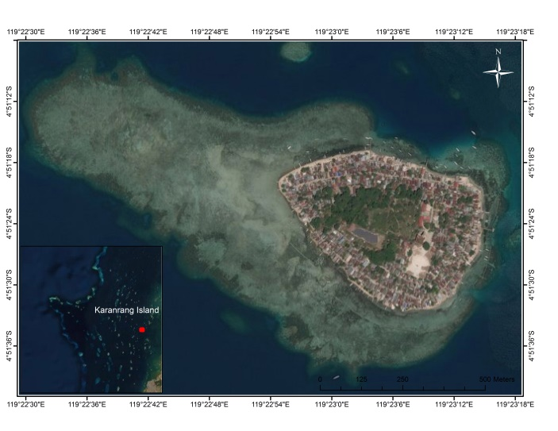

**Figure 1.** Karanrang Island

***Sample Preparation***

Physical cleaning, sediment was cleaned with distilled water to prevent contamination. Then, the sediment was dried and crushed by mortar.

***Analysis with Fourier-Transform Infrared (FT-IR)***

Sample sediment and potassium bromide were mixed with a ratio of 1:10. Then, the mixture was compressed to form a pellet. The sample was analyzed with Shimadzu FT-IR type IRPrestige-21 (spectral range 340-4000 cm-1). FT-IR analysis was used to identify constituent bonds of sediment (Meftah & Mahboub, 2019).

***Analysis with X-Ray Fluorescence (XRF) and X-Ray Diffraction (XRD)***

Sediment was compressed under high pressure to form a pellet for a few minutes (Brinatti et al., 2010). Then, the sediment was analyzed with XRF.

Instrument XRD can be utilized to evaluate the characteristics of XRD. Sediment uses the Rietveld Process with an experiment condition voltage of 40 kV with 30 mA. Scanning from 20-70 oC with a time step of 0.6 seconds and continuous scanning speed (Meftah and Mahboub, 2019).

**RESULTS AND DISCUSSION**

## Fourier-Transform Infrared Analysis

The infrared spectrum of the sediment samples is illustrated in Figure 2. FT-IR Spectrum can identify the functional group of sediment.

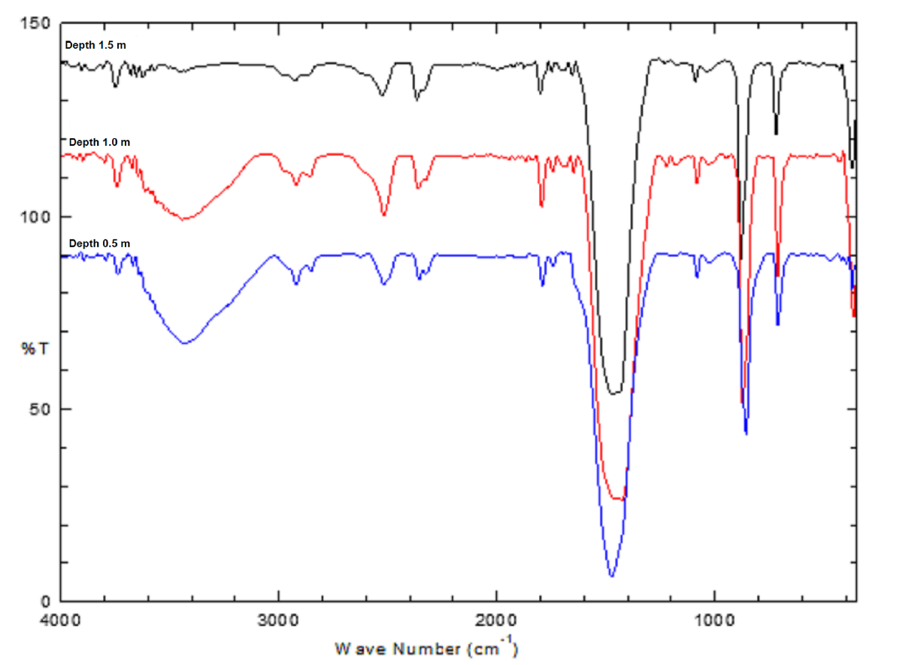

**Figure 2.** Spectrum FT-IR absorption of sediment in Karanrang Island

with depth (0.5; 1.0 and 1.5) m

FT-IR technique investigates a high-intensity absorption band at 3441 (A), 3444 cm-1 (B), and 3444 cm-1 (C), which are due to stretching vibrations OH. These are supported by H-O-H water, which reveals the absorption of wavenumbers 1683 cm-1 (B), 1647 cm-1 (B) and 1683 cm-1 (C), 1649 cm-1 (C) (Meftah & Mahboub, 2019; Saikia & Partasaranthy, 2010).

The 2920 cm-1 (A), 2852 cm-1 (A); 2976 cm-1 (B), 2920 cm-1 (B), 2856 cm-1 (B); and 2974 cm-1 (C), 2920 cm-1 (C), 2875 cm-1 (C) wavenumber features are due to C-H stretching vibration derived from organic compounds appearing in the area (Meftah & Mahboub, 2019).

Three absorption bands (CO3)2-, are asymmetrical and symmetrical stretching vibrations which have been observed at wavenumber 2520 cm-1 (A), 1791 cm-1 (A), 1743 cm-1 (A); 2519 cm-1 (B), 1795 cm-1 (B), 1743 cm-1 (B) and 2520 cm-1 (C), 1793 cm-1 (C), 1743 cm-1 (C). These are supported by absorption at wavelengths 1473 cm-1 (A), 1425 cm-1 (B) and 1460 cm-1 (C). Wavenumbers 856 cm-1 (A), 873 cm-1 (B), and 873 cm-1 (C) correspond to the C=O stretching mode vibration (Gnanasin & Rajkumar, 2013).

Quartz is a form of minerals. Its chemical formula is SiO2. The presence of quartz may be identified with the Si-O bond. Si-O bond is the strongest in silicate minerals. The Si-O bond in the region 900-1100 cm-1 is due to stretching mode, and in the range of 400-800 cm-1 is due to bending mode (13). The absorption at the wavenumbers 1082 cm-1 (A), 1082 cm-1 (B), and 1082 cm-1 (C) are due to the presence of Si-O-Si (symmetrical stretching) (Meftah and Mahboub, 2019). Supported by absorption of Si-O (bending vibrations) at wavenumbers 433 cm-1 (B) and 422 cm-1 (C) (Hlayvay et al., 1977).

The spectrum of wavenumbers 1028 cm-1 (A), 1029 cm-1 (B), 1031 cm-1 indicated the occurrence of Sr-O-Sr stretching vibration (Granados-Correa & Bonifacio-Martinez, 2014), supported by absorptions Sr-O at wavenumbers 711 cm-1 (A), 711 cm-1 (B) and 713 cm-1 (C) (Lee et al., 2018). **Table 1**. shows the functional group found in sediment.

**Table 1**. The main bands of IR spectrum

|  |  |  |  |  |
| --- | --- | --- | --- | --- |
| **Band (cm-1)** | | | **Bond** | **Compound** |
| **(A)**  **Depth 0,5 m** | **(B)**  **Depth 1 m** | **(C)**  **Depth 1,5 m** |
| 3441 | 3444 | 3444 | H-O-H | Water |
| - | 2976 | 2974 | C-H | organic carbon |
| 2920 | 2920 | 2920 | C-H | organic carbon |
| 2852 | 2856 | 2875 | C-H | organic carbon |
| 2520 | 2519 | 2520 | (CO3)2- | Aragonite |
| 1791 | 1795 | 1793 | (CO3)2- | Aragonite |
| - | 1683 | 1683 | H-OH | Water |
| - | 1647 | 1649 | H-OH | Water |
| 1473 | 1456 | 1460 | (CO3)2- | Aragonite |
| 1082 | 1082 | 1082 | Si-O-Si | Quartz |
| 1028 | 1029 | 1031 | Sr-O-Sr | Strontium oxide |
| 856 | 873 | 873 | (CO3)2- | Aragonite |
| 711 | 711 | 713 | Sr-O | Strontium oxide |
| 470 | - | - | Si-O-Si | Quartz |
| 420 | 433 | 422 | Si-O | Quartz |

## X-Ray Fluorescence Analysis and X-Ray Diffraction Analysis

Based on **Table 2**, mineral content in sediment from Karanrang Island are CaO, CaCO3, Si, SiO2, SrO and Sr. CaCO3 is the highest percentage in sediment due to the composition of coral and various other carbonate-producing organisms. Generally, sediment in Reef Island is composed of a mixture of coral, coralline, mollusks, foraminifera, and *Halimeda* (Kench et al., 2017, Janßen et al., 2017).

**Table 2.** Mineral content percentage of sediment in Karanrang Island

with XRF instrument

|  |  |  |  |
| --- | --- | --- | --- |
| ***Mineral Content (%)*** | ***Karanrang Island*** | | |
| ***Depth 0,5 m*** | ***Depth 1 m*** | ***Depth 1,5 m*** |
| CaO | 11.02 | 11.20 | 12.11 |
| CaCO3 | 49.72 | 51.84 | 53.57 |
| Si | 2.89 | 3.53 | 3.43 |
| SiO2 | 11.02 | 11.04 | 9.96 |
| Sr | 10.19 | 7.52 | 10.03 |
| SrO | 12.40 | 11.96 | 9.15 |

Diffractogram (Figure 3) shows the XRD pattern in sediment samples from Karanrang Island. The analysis results obtained were compared with standards to determine the mineral content contained in sediments using JCPDS (*Joint Committee Powder Diffraction Standard*) 96-500-0086.

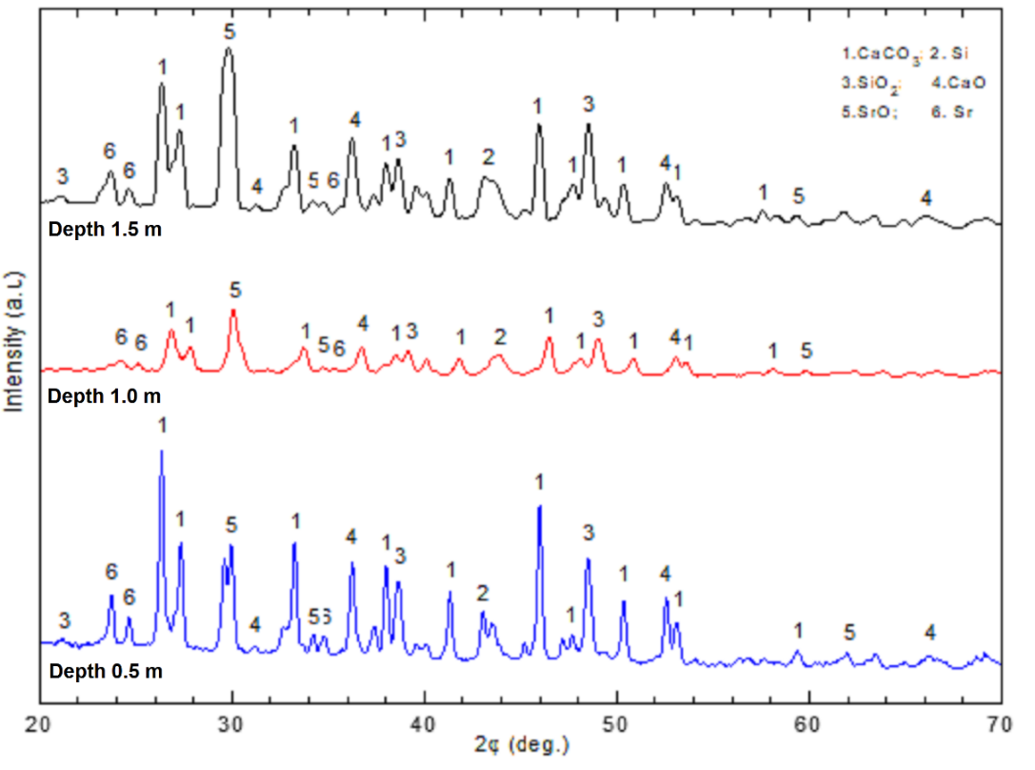

**Figure 3**. XRD result of sediment in Karanrang Island with depth (0.5; 1.0 and 1.5) m

The XRD result agreed with XRF and FT-IR spectroscopy, confirming that the dominant phase in the sediment from Karanrang Island is calcium carbonate. Based on **Figure 3**, it can be seen that there is no significant difference in the XRD diffractogram; the only difference is that the intensity is correlated to the concentration of minerals in the sediment sample (Chung & Smith, 1999).

**CONCLUSIONS**

Based on the analysis of oxide and mineral content in sediments on Karanrang Island, the highest sediment content is CaCO3. It can be concluded that sediment in Karanrang Island can be used as a sample for measuring 14C activity.

**ACKNOWLEDGMENTS**

This research was funded by The Indonesian Ministry of Research, Technology and Higher Education (RISTEKDIKTI) with the Research Contract No. 739/UN4.21/PL.01.10/2019. We gratefully acknowledge our supervisor, Prof. Alfian Noor, M.Sc., Triangle Diving Club for sampling, FT-IR, XRF and XRD laboratory assistants (Faculty of Mathematics and Natural Sciences, Hasanuddin University) for the analysis process.

**REFERENCES**

Anbalagan, G., Prabakaran, A. R., & Gunasekaran. 2010. Spectroscopic Characterization of Indian Standard Sand. *Journal of Applied Spectroscopy*, 77(1), 95-103.

Brinatti, A. M., Mascarenhas, Y. P., Pereira, V. P., Partiti, C. S. D. M., & Macedo, A. 2010. Mineralogical Characterization of A Highly-Weathered Soil by the Rietveld Method. *Sci. Agrid.,* 67(4),454-464.

Chung, F. H., & Smith, D. K. 1999. *Industrial Applications of X-Ray Diffraction,* CRC Press New York.

Gnanasaravanan, S., & Rajkumar, P. 2013. Characterization of minerals in natural and manufactured sand in Cauvery River belt, Tamilnadu, India. *Infrared Phys. Technol.,* 58, 21–31.

Granados-Correa, F., & Bonifacio-Martinez, J. 2014. Combustion Synthesis Process for the Rapid Preparation of High-Purity SrO Powders. *Materials Science-Poland*, 32**,** 682-687.

Guta, S., K., & Polach, H. A., 1985. Radiocarbon Dating Practice at Australian National University. Handbook Radiocarbon Dating Laboratory. Research School of Pacific Studies. ANU. Canberra.

Hlayvay, J., Jonas, K., Elek, S., & Inczedy, J. 1977. Characterization of The Particle Size and The Crystallinity of Certain Minerals by Infrared Spectrophotometry and Other Instrumental Method-I. Investigations on Clay Minerals. *Clay and Clay Minerals*, 25, 451-456

Hopley, D. 2011. *Encyclopedia of Modern Coral Reef*. *Springer Science* <http://doi.org/10.1007/978-90-481-2639-2>

Imran, A. M., Kaharuddin, M. S., Sumihardja, D. A., and Sirajuddin. 2013. Geology of Spermonde Platform. *Proceedings of the 7th International Conference on Asian and Pacific Coast*.

Janßen, A., Wizemann, A., Klicpera, A., Satari, D. Y., Westphal, H., & Mann, T., 2017. Sediment Composition and Facies of Coral Reef Islands in the Spermonde Archipelago, Indonesia. *Frontier in Marine Science*, 4, 1-13.

Kench, P. S., McLean, R. F., & Nichol, S. L. 2005. New Model of Reef-island Evolution: Maldives, Indian Ocean. *Geological Society of America*, 33(2), 145-148

Kench, S., Smithers, S. G., McLean, R. F., & Nichol, S. L. 2009. Holocene Reef Growth in the Maldives: Evidence of a mid-Holocene sea-level Highstand in the Central Indian Ocean. *Geology*, 37(5), 455-458

Kench, P. S., Smithers, S. G., & McLean, R. F. 2012. Rapid Ref Island Formation and Stability Over An Emerging Reef Flat: Bewick Cay, Northern Great Barrier Reef, Australia. *Geology*, 40(4), 347-350

Kench, P. S., Owen, S. D., & Ford, M. R., 2014. Evidence for Coral Island Formation during Rising Sea Level in the Central Pacific Ocean *Geophys. Res. Lett.,* 41, 820-827.

Kench, P. S., & Mann, T. 2017. Reef Island Evolution and Dynamic: Insights from the Indian and Pacific Oceans and Perspectives for the Spermonde Archipelago *Frontiers in Marine Science,* 4, 1-17.

Lee, H., Liao, J., Lee, M. H., Liu, B. H., Fu, W., Sivashanmugan, K., & Juang, Y., 2018. Strontium Oxide Deposited onto a Load-Bearable and Porous Titanium Matrix as Dynamic and High-Surface-Contact-Area Catalysis for Transesterification *Nanomaterial*, 8(12),2-14.

Meftah, N., & Mahboub, M. S. 2019. Spectroscopic Characterizations of Sand Dunes Minerals of El-Oued (Northeast Algerian Sahara) by FTIR, XRF and XRD Analysis. *Silicon*, http://doi.org/10.1007/s12633-019-00109-5.

Saikia, B. J., & Parthasarathy, G. 2010. Fourier Transform Infrared Spectroscopic Characterization of Kaolinite from Assam and Meghalaya, Northeastern India *J. Mod. Phys*., 1(4), 206-210.

Suriamihardja, D. A. 2011. Coral Reef Island of Spermonde: Morphodynamics and Prospect Proceedings of the Sixth International Conference on Asian and Pacific Coast (APAC 2011).