**Characterization of Volatile Compounds of Selected Aromatic Plants from West Java**

**Aika Latifah Alawiyah*, Sifa Sidiqoh, Imas Rohaeni, Desri Yulianti Savitri, Risda Widana**

Departemen of Chemistry, Faculty of Mathematics and Natural Science, Garut University, Tarogong Kaler, Garut, 44151, Indonesia

*\*Corresponding Author: aikalatifah@uniga.ac.id*

Received: Juny, 1, 2024/Accepted: December, 22, 2024

doi:10.24252/al-kimia.v12i2.47840

***Abstract:*** *Chrysopogon zizanioides (Poaceae), Pogostemon cablin (Lamiaceae), Cymbopogon nardus (Poaceae), and Citrus reticulate (Rutaceae) have an abundance of essential oils and major commodities in Garut, West Java. The knowledge of chemical compositions could lead to understanding complex mixtures of organic compounds that give plants characteristic odor, flavor, and potency. This study aimed to identify the chemical composition of the essential oils of C. zizanioides (roots), P. cabin (leaves), C. nardus (stems), and C. reticulate (leaves and peel). The essential oils were distilled using the hydro distillation method. The chemical composition of essential oils was analyzed by Gas Chromatography-Massa Spectrometry (GC-MS). The results showed that the dominant major compounds in the essential oil of C. zizanioides roots included valerenal (14.81%). Patchouli alcohol (33.23%) and E-citral (36.18%) were found in P. cabin leaves and C. nardus stems, respectively. The essential oil of C. reticulate leaves and peel contained the major compounds, namely limonene, with a percentage of 30.98% for leaves and 82.58% for peel. Sesquiterpenes were the dominant compounds found in C. zizanioides root and P. cabin leaves oil, while monoterpenes were the major compounds in C. nardus stem, C. reticulate leaves, and peel.*

***Keywords****: Aromatic Plant, Citral, Limonene, Patchouli Alcohol, Valerenal.*

**INTRODUCTION**

Aromatic plants are a class of plants that exude aromatic substances as essential oils used for cooking, tea, natural medicines, and perfume industries. The essential oils from various aromatic plants have potential because they contain terpenoid compounds, which have been tested for their presence in these plants (Sa’adah et al., 2019). Essential oils are distributed in several families, such as Myrtaceae, Lauraceae, Rutaceae, Lamiaceae, Asteraceae, Apiaceae, Poaceae, Zingiberaceae, and Piperaceae. The bioactivity of essential oils has been known for a long time and has been applied in health, agriculture, food, and the cosmetics industry. Some of these volatile compounds exhibit antifungal activities. Antifungal activity has been studied against targets of aromatic plants such as the essential oil from some species of the genera *Pogostemon, Lavandula, Mentha, Thymbra*, and *Thymus*. *Pogostemon* *cablin* has good activities (minimum inhibitory concentrations (MICs) < 1000 µg/mL) against *Aspergillus niger, Candida albicans, Candida krusei, Candida tropicalis,* and *Cryptococcus neoformans* (Karpi, 2020). Anticancer effects have been reported in several studies, one of which is an essential oil from *Gannanzao oranges*, which showed inhibition of hepatoma and colorectal cell proliferation (Mancianti, 2020). *Geranial* and *neral* have been isolated from the essential oils of *C*. *citratus*. They are effective against gram-positive and harmful bacteria such as *Clostridium botulinum, Campylobacter jejuni, Escherichia coli, Salmonella, and Listeria monocytogenes* (Solomon et al., 2019). Essential oils from *C. citratus, C. nardus,* and *C. schoenanthus* have sound antifungal and anti-aflatoxinogenic effects against both *Aspergillus flavus* and Aspergillus *parasiticus* (Sawadogo et al., 2022).

*C. zizanioides,* P*. cablin,* C*. nardus,* and *C. reticulate* are aromatic plants abundant in Garut, West Java. These plants produce essential oils exported as raw materials for perfumes, cosmetics, antiseptics, and insecticides (Mudaki, 2018). The Poaceae, Lamiaceae, and Rutaceae are rich in essential oils (Campolo et al., 2018). The essential oils contain significant terpenoid compounds that have potential in the health, agriculture, cosmetics industry, etc (Das et al., 2013; David et al., 2019). The presence of terpene in essential oils plays an important role in their bioactivity. Valerenol, vale-renal, and β-cadinene are the major compounds in C. *zizanioides* oil (David et al., 2019). Patchoulol, α-bullseye, caryophyllene, and α-guanine were the major compounds in the essential oils of P. *cabin* leaves (Albuquerque et al., 2013). Citronellol, geraniol, and β-elements are major compounds in C. *nardus* leaves (Sawadogo et al., 2022). Most volatile compounds found in various Citrus species, including C. *reticulate*, are terpenoid (90%) (González-mas et al., 2019).

The demand for essential oils is increasing because of their potential application in pharmacology and industry. The yield and compounds of essential oils in plants can be influenced by factors including the growing environment, climate, harvest time, and the part of the plant used for essential oil extraction (Achmad et al., 2018). David et al., 2019 reported that the distillation of C. *zizanioides* essential oil from China produced an oil yield of 0.6%. The study by Daniati et al., 2021 shows that patchouli oil from Perunaron Aceh yielded 2.04%. Previous research was also carried out on Tangerine leaves (C. *reticulata*), resulting in a yield of 1.12% (Ali et al., 2021) and 8.11 % for C. *nardus* stems from Denpasar (Muksin, 2017). Therefore, before studying the bioactivity of plant extracts, it is necessary to conduct a study to determine the chemical composition of essential oils in plants. This study aimed to determine the chemical compositions of essential oils from C. *zizanioides*, P. *cabin*, C. *nardus*, and C. *reticulate* plants distilled by hydrodistillation*.*

**RESEARCH METHODS**

**Materials and Tools**

A Fresh sample of *C. zizanoides* (L.) Roberty roots, *P. cablin* Benth. Leaves, leaves, and peels of *C. reticulate* were collected from different places. The roots of the *C. zizanoides* (L.) Roberty was obtained from Samarang, and the leaves of *P. cabin* Benth were taken from plantations in the Cibalong area. At the same time, the *C. nardus* (stems) and *C. reticulate* (leaves and peel) were obtained from Tarogong Kaler, West Java. The plants were identified and deposited at Jatinangoriense Herbarium, Biosystematics and Molecular Laboratory, Department of Biology, Faculty of Mathematics and Natural Sciences, Padjadjaran University. The authentication process was carried out to determine the identity of the plant. Aquadest was used as a solvent for the extraction of essential oils.

The equipment used in this study includes analytical balance, a simple laboratory quick fit apparatus with 2000 mL for bio flask and boiling flask, a condenser tube, a receiver/separator oil water, a heating mantle, vials, beaker glass, and a set of tools for Gas Chromatography-Mass Spectrometry (GC-MS) brand SHIMADZU® (GCMS-QP 2010 Ultra).

**Methods**

***Preparation of sample***

The roots of *C. zizanoides* (L.) RobertyThe roots are cleaned with water to remove adhering lumps of soil, then dried for 1 day at room temperature to evaporate the water content. The dried roots are sorted and cut into small pieces. *Pogostemon cablin* Benth (leaves), *C. nardus* (stems), and *C. reticulate* (leaves and peel) were prepared fresh, then washed, sorted, and chopped into small pieces.

***Extraction of essential oils***

Essential oils were extracted from fresh roots of *C. zizanoides* (L.) Roberty  (1093 g), stems of *C. nardus* (1650 g), leaves of *P. cablin* Benth (600 g), leaves (1589 g) and peel (2000 g) of *C. reticulata* by the hydrodistillation method using a simple laboratory quickfit apparatus (Abram et al., 2021; Albuquerque et al., 2013). The essential oil was separated from the aqueous phase and stored in a vial and freezer until used.

***Analysis of essential oils by GC-MS***

The chemical composition of essential oils was analyzed using *GC-MS* SHIMADZU (GCMS-QP 2010 Ultra). Each essential oil sample (0.2 μL) was injected. The column used is *Dura Bond* (DB5). The oven temperature was programmed from 60℃ to 280℃ at a rate of 8℃/min for integrating purposes. Injector and detector temperatures were 280℃ and 290℃ respectively. Helium was used as the carrier gas with 80.2 kpa inlet pressure. The flow rate was 1.31 mL/min. The constituents were identified by comparing their mass spectra with data from the WILLEY (Mass Spectra Library).

**RESULTS AND DISCUSSION**

Essential oils obtained from distillation of *C. zizanoides* (L.) Roberty (roots), *P. cablin* Benth (leaves), *C. nardus* (stems), and *C. reticulate* (leaves and peel) are shown in Figure 1. The yields of their essential oils were 0.5 % w/w, 1.32 w/w, 0.58% w/w, 0.18 % w/w, and 1.6 % w/w, respectively, based on dry sample weight. Gogoi et al., 2023 reported that essential oil distilled from the roots of *C. zizanoides* produced a yield of 0.11%. However, this differs from the oil isolation results by Oliveira et al., 2022 and Hassane Soidrou et al., 2020 which showed higher yields, 0.52%, and 1%, respectively. Several factors influence differences in the yield of essential oils from plants in each region. These factors include intrinsic factors (age of harvested plants, time of harvest, quality of simplicia used, distillation methods and processes) and external (climate, geographical conditions, interspecific and intraspecific changes).

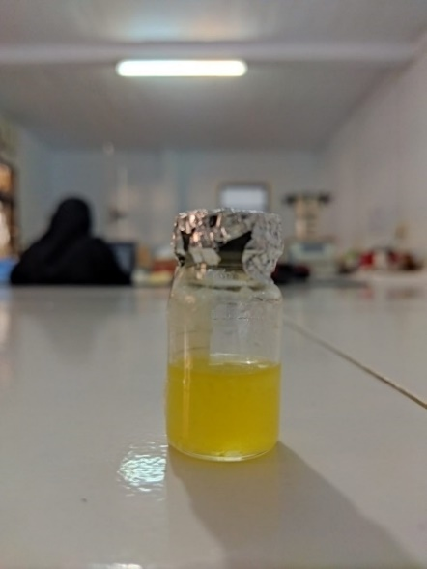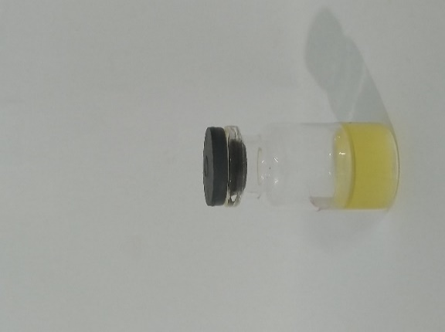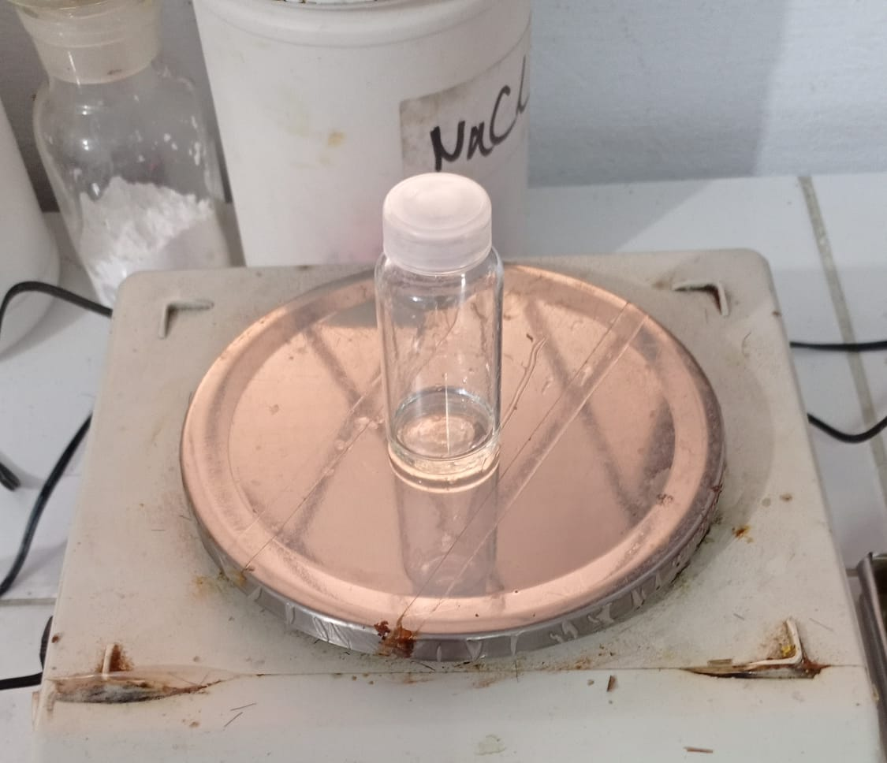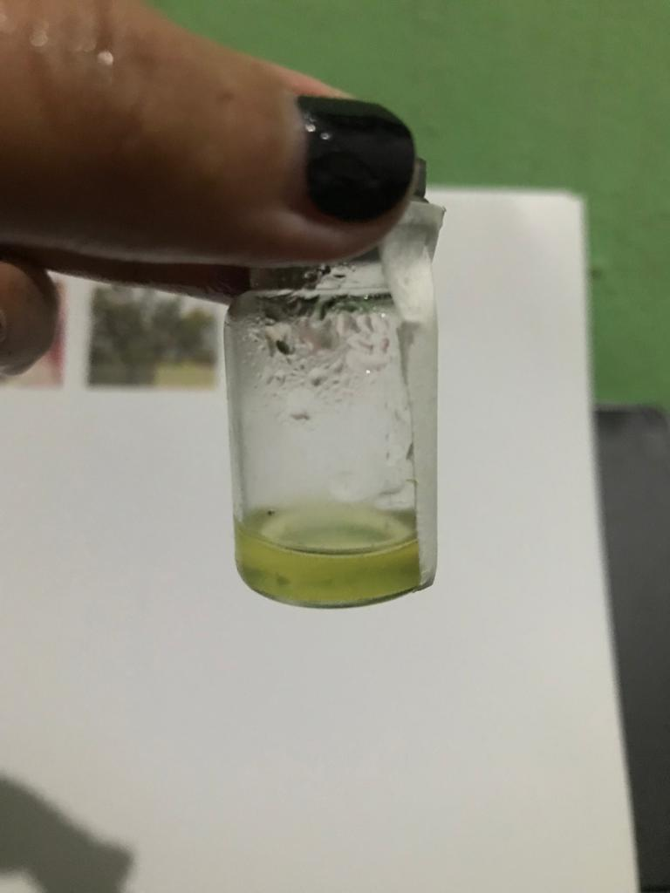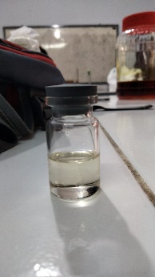

1. (b) (c) (d) (e)

**Figure 1.** Essential oils of (a) *C. zizanoides* (L.) Roberty roots, (b) *P. cablin* Benth leaves, (c) *C. nardus* stems (d) *C. reticulate* leaves, (e) *C. reticulate* peel

The composition of essential oils from various aromatic plants growing in Garut, West Java was analyzed qualitatively and quantitatively using GC-MS.

The chemical components and compound percentages of the essential oils of *C. zizanoides* (L.) Roberty roots (Table 1), *P. cablin* Benth leaves (Table 2), *C. nardus* stems (Table 3), *C. reticulate* leaves (Table 4), and *C. reticulate peel* (Table 5) were listed.

**Table 1.** Chemical compounds of essential oil from *C. zizanoides* (L.) Roberty roots

| Retention Time (RT) | Area (%) | Compounds | Class of component |
| --- | --- | --- | --- |
| 12.258 | 2.93 | *Cyclohexasiloxane* | siloxane |
| 14.232 | 0.54 | *Octahydro-1,7a-dimethyl-5-(1-methylethyl)* | Sesquiterpene |
| 14.937 | 0.43 | $α$*-Chamigrene* | sesquiterpene |
| 15.119 | 0.92 | $β$*-Funebrene* | sesquiterpene |
| 15.184 | 0.46 | $γ$*- Cadinene* | sesquiterpene |
| 15.279 | 0.76 | $β$*-Cedrene* | sesquiterpene |
| 15.489 | 0.26 | *Aristolen* | sesquiterpene |
| 15.747 | 4.34 | *Sativen* | sesquiterpene |
| 15.839 | 4.37 | *Khusimene* | sesquiterpene |
| 16.025 | 1.15 | *L-Proline* | Amino acid |
| 16.128 | 2.06 | $α$*-Amorphene* | sesquiterpene |
| 16.313 | 0.56 | $δ$*-Selinene* | sesquiterpene |
| 16.376 | 1.38 | $α$*-Copaene* | sesquiterpene |
| 16.912 | 3.82 | $α$*-Gurjunene* | sesquiterpene |
| 17.136 | 0.42 | *Aromadendren* | sesquiterpene |
| 17.305 | 1.37 | *L-Valine* | Amino acid |
| 17.550 | 0.62 | $β$*-Maaliene* | Sesquiterpene |
| 17.617 | 2.52 | *Rosifoliol* | Sesquiterpene |
| 17.910 | 1.14 | *4,4-Dimethyl-3-(3-methyl-3-buten-1-ylidene)-2-methylidene bicyclo [4.1.0] heptane* | Sesquiterpene |
| 18.339 | 1.27 | *Eremophilene* | sesquiterpene |
| 18.569 | 7.99 | *Spathulenol* | Sesquiterpene |
| 18.726 | 1.79 | *Guaiol* | Sesquiterpene |
| 18.980 | 2.09 | *Trans-Caryophyllene* | Sesquiterpene |
| 19.124 | 5.51 | *Veridiflorol* | Sesquiterpene |
| 19.240 | 0.64 | *Diacetoxyscirpenol* | Sesquiterpene |
| 19.721 | 1.98 | *8-isopropenyl-1,3,3,7-tetramethyl-bicyclo[5.1.0]oct-5-en-2-one* | Sesquiterpene |
| 19.775 | 1.12 | *junipercamphor* | Sesquiterpene |
| 20.102 | 0.44 | *isosativene* | Sesquiterpene |
| 20.576 | 1.12 | *Humulen* | Sesquiterpene |
| 21.115 | 2.28 | *4-Bromo-1-naphthylamine* | *naphthylamine* |
| 21.307 | 2.26 | *Tricyclo[5.1.0.0(2,4)]oct-5-ene-5-propanoic acid, 3,3,8,8-tetramethyl* | Sesquiterpene |
| 21.385 | 0.70 | *Nootkatone* | Sesquiterpene |
| 21.518 | 3.26 | *6-Isopropenyl-4,8a-Dimethyl-3,5,6,7,8,8a-Hexahydro-1h-Naphthalen-2-One* | Sesquiterpene |
| 21.707 | 14.81 | *Valerenal* | Sesquiterpene |
| 21.795 | 6.16 | *Cembrene* | diterpene |
| 21.932 | 10.10 | Zierone | Sesquiterpene |

**Table 2**. Chemical compounds of essential oil from *P. cablin* Benth leaves

| Retention Time (RT) | Area (%) | Compounds | Class of component |
| --- | --- | --- | --- |
| 7.512 | 0.05 | *Limonene* | Monoterpene |
| 10.116 | 0.14 | *Acetic-acid, phenylmethyl ester (CAS) benzyl acetate* | *ester* |
| 13.558 | 0.13 | $δ$*-elemene* | Sesquiterpene |
| 14.554 | 2.93 | $β$*-patchoulene* | Sesquiterpene |
| 15.129 | 0.80 | *1H-3a,7-methanoazulene, 2,3,4,7,8, 8a-hexahydro-3,6,8, 8-tetramethyl* | Sesquiterpene |
| 15.206 | 4.19 | *Trans-caryophellene* | Sesquiterpene |
| 15.441 | 14.76 | $α$*-guaiene* | Sesquiterpene |
| 15.510 | 0.08 | *Epi- $α$-Patchoulene* | Sesquiterpene |
| 15.600 | 0.22 | $δ$*-guaiene* | Sesquiterpene |
| 15.655 | 0.14 | *Germacrene* | Sesquiterpene |
| 15.748 | 8.21 | *Seychellene* | Sesquiterpene |
| 15.807 | 0.83 | *Humulen* | Sesquiterpene |
| 15.958 | 6.36 | $α$*-patchoulene* | Sesquiterpene |
| 16.010 | 2.16 | *1,2,4-metheno-1H-indene, octahydro-1,7a-dimethyl-5-(1-methylethyl)* | Sesquiterpene |
| 16.069 | 2.56 | *Alloaromadendren* | Sesquiterpene |
| 16.188 | 0.16 | $γ$*-gurjunene* | Sesquiterpene |
| 16.342 | 0.71 | *Eremophilene* | Sesquiterpene |
| 16.900 | 0.23 | $α$*-panasinsen* | Sesquiterpene |
| 17.739 | 0.09 | *1H-cycloprop[e]azulen-4-ol, decahydro-1,1,4,7-tetramethyl* | Sesquiterpene |
| 17.950 | 0.09 | *spathulenol* | Sesquiterpene |
| 18.407 | 0.39 | *caryophyllene oxide* | Sesquiterpene |
| 19.515 | 33.23 | *Patchouli alcohol* | Sesquiterpene |
| 21.097 | 0.09 | *3,7,11-trimethyl-dedoca-2,4,6,10-tetraenal* | Sesquiterpene |

**Table. 3** Chemical compounds of essential oil from *C. nardus* stems

| Retention Time (RT) | Area (%) | Senyawa | Class of component |
| --- | --- | --- | --- |
| 1.454 | 0.24 | *2-Propanone (Acetone)* | Ketone/alkanone |
| 6.536 | 0.41 | *6-Methyl-5-hepten-2-one* | Ketone |
| 6.638 | 2.95 | *β-Myrcene* | Monoterpene |
| 7.524 | 0.15 | *cis-Ocimene* | Monoterpene |
| 7.748 | 0.10 | 3,7-dimethyl-1,3,6-Octatriene  *(trans-β-Ocimene)* | Monoterpene |
| 8.799 | 0.59 | *Linalool* | Monoterpene alcohol |
| 9.010 | 1.83 | *Decamethyl-Cyclopentasiloxane (Dimethylsiloxane pentamer)* | Siloxane |
| 9.679 | 0.30 | *3,3,5-trimethyl-1,4-Hexadiene* | Alkadiene |
| 9.838 | 0.45 | *Citronella* | Monoterpene aldehyde |
| 10.049 | 0.62 | *4,5-Epoxycarane* | Monoterpene epoxide |
| 10.389 | 1.10 | *4,5-Epoxycarane* | Monoterpene epoxide |
| 11.650 | 23.83 | *Z-Citral* | Monoterpene aldehyde |
| 12.204 | 36.18 | *E-Citral* | Monoterpene aldehyde |
| 12.335 | 1.99 | *trans-Geraniol* | Monoterpene alcohol |
| 12.426 | 0.98 | *Epoxy-linalooloxide* | Monoterpene epoxide |
| 12.528 | 0.47 | *Epoxy-linalooloxide* | Monoterpene epoxide |
| 12.785 | 2.59 | *Dodecamethylcyclohexasiloxane* | Siloxane |
| 13.043 | 0.66 | *Neric acid* | Fatty acid |
| 13.545 | 0.36 | *1-methylene-2-trimethylsilyl-cyclopropane* | Cycloalkene |
| 13.666 | 3.15 | *Geranic acid* | Polyunsaturated fatty acid |
| 14.092 | 1.81 | *Geranyl acetate* | Ester monoterpenoid |
| 15.246 | 0.15 | *α-Bergamotene* | Sesquiterpene |
| 15.910 | 0.51 | *Tetradecamethylcyclo-heptasiloxane* | Siloxane/polysiloxane |
| 16.718 | 0.31 | *α-Cedrol* | Monoterpene alcohol |
| 16.786 | 0.30 | *Δ-Cadinene* | Sesquiterpene |
| 17.978 | 0.32 | *(-)-Caryophyllene oxide* | Sesquiterpene oxide |
| 18.261 | 1.18 | *1,2,3,4,4a,5,6,7-octahydro-α,α,4a,8-tetramethyl,2-naphthalenemethanol* | Terpenoide |
| 18.526 | 6.35 | *Juniper champor* | Sesquiterpene |
| 18.775 | 2.91 | *Guaiol* | Monoterpene alcohol |
| 18.875 | 0.57 | *Agaruspirol* | Sesquiterpene alcohol |
| 19.022 | 3.74 | *t-Muurolol* | Sesquiterpene alcohol |
| 19.199 | 1.51 | *Juniper champor* | Sesquiterpene |
| 19.734 | 0.36 | *Juniper champor* | Sesquiterpene |
| 20.036 | 0.18 | *trans, trans-Farnesal* | Alkenal/ aliphatic aldehyde |
| 20.122 | 0.35 | *6-methyl-5-(1-methylethyl)-5-Hepten-3-yn-2-ol* | Alkin alkohol |
| 21.487 | 0.33 | *4,6,10,10-teramethyl-5-oxa-tricyclo[4.4.0.0 1,4]-dec-2-en-7-ol* | Terpenoid |

**Table 4**. Chemical compounds of essential oil from *C. reticulate* leaves

|  |  |  |  |
| --- | --- | --- | --- |
| Retention Time (RT) | Area (%) | Senyawa | Class of component |
| 5.538 | 0.21 | *α –thujene* | Monoterpene |
| 5.724 | 10.38 | *α-Pinene* | Monoterpene |
| 6.453 | 17.29 | *β –phellandrene* | Monoterpene |
| 6.561 | 2.36 | *β-Pinene* | Monoterpene |
| 6.646 | 2.56 | *β-Myrcene* | Monoterpene |
| 7.152 | 1.36 | $δ-$*3-Carene* | Monoterpene |
| 7.255 | 0.47 | *(+)-2-Caren* | Monoterpene |
| 7.412 | 0.34 | $ο$*-cymene* | Monoterpene |
| 7.545 | 30.98 | *Limonene* | Monoterpene |
| 7.769 | 7.21 | *β-Ocimen* | Monoterpene |
| 8.070 | 1.76 | *γ.-Terpinene* | Monoterpene |
| 8.678 | 0.66 | *α –Terpinolene* | Monoterpene |
| 8.903 | 11.84 | *Linalool* | Monoterpene |
| 10.842 | 1.06 | *Decanal* | Aldehyde |
| 11.462 | 1.21 | *Methyl Thymylether* | eter |
| 13.536 | 0.32 | $δ$*-elemene* | Sesquiterpene |
| 14.538 | 0.53 | *β-Elemene* | Sesquiterpene |
| 15.173 | 0.63 | *Trans-caryophellene* | Sesquiterpene |
| 15.435 | 0.40 | *β –Farnesene* | Sesquiterpene |
| 15.766 | 0.21 | *Humulen* | Sesquiterpene |
| 16.208 | 0.47 | *Germacrene* | Sesquiterpene |
| 16.302 | 0.31 | *Farnesene* | Sesquiterpene |
| 16.470 | 2.24 | *bicyclogermacrene* | Sesquiterpene |
| 16.794 | 0.21 | $δ$*-Cadinene* | Sesquiterpene |
| 19.419 | 2.85 | *β –Sinensal* | Sesquiterpene |
| 20.226 | 1.91 | *α- sinensal* | Sesquiterpene |

**Table 5**. Chemical compounds of essential oil from *C. reticulate* peel

| Retention Time (RT) | Area (%) | Compounds | Class of component |
| --- | --- | --- | --- |
| 4.510 | 0.86 | *α-Pinene* | Monoterpene |
| 5.101 | 1.41 | *Sabinene* | Monoterpene |
| 5.211 | 8.89 | *β-Pinene* | Monoterpene |
| 5.268 | 3.01 | *β-Myrcene* | Monoterpene |
| 5.447 | 1.30 | Octanal | Aldehyde |
| 6.068 | 82.58 | Limonene | Monoterpene |
| 6.226 | 0.41 | *β-Ocimen* | Monoterpenen |
| 7.189 | 0.45 | *Nonanal* | Aldehyde |
| 7.724 | 0.20 | *para-Mentha-1,5,8-triene* | Monoterpene |
| 8.073 | 0.17 | *Citronella* | Monoterpene |
| 8.984 | 0.23 | *Decanal* | Aldehyde |
| 12.385 | 0.49 | *β-Elemene* | Sesquiterpene |

Table 1 shows the seven major compounds of essential oils from *C. zizanoides* (L.) Roberty roots included valerenal (Figure 2a) with the highest composition, namely 14.81%, followed by spathulenol (7.99%), veridiflorol (5.51%), khusimene (4.37%), sativen (4.34%), 6-isopropenil-4,8a-dimethyl-3,5,6,7,8,8a-hexahydro-1h-naphthalen-2-one (3.26%), 4-bromo -1-naphthylamine (2.28%). Previous reports are also consistent with our study. However, it shows variations in the percentage composition, namely valerenal (10.21%) (David et al., 2019). In another study by (Lima et al., 2012) indicated the presence of khusimol (19.57%), E-isovalencenol (13.24%), α-vetivone (5.25%), vetiselinenol (5.08%), α-cadinol (5.01%), α-vetivone (4.87%) and hydroxy-valencene (4.64%) as the major compounds in essential oil of *C. zizanoides* (L.) Roberty roots. The same statement as Oliveira et al., 2022, khusimol (30) is the dominant component in essential oils. Almost all of the major compounds of *C. zizanoides* (L.) Roberty oil consist of sesquiterpene compounds with a percentage of 86%. Some of these volatile compounds were identified as the major compounds that are considered to be characteristics of the oil (Pripdeevech et al., 2006).



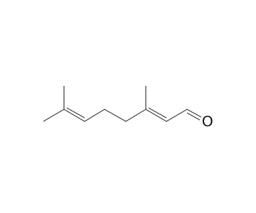

(d)

**Figure 2**. Compounds structure of the Valerenal (a), Patchouli alcohol (b), Limonene (c), and (d) *E-*Citral

The results of GC-MS analysis showed that the major compounds of *P. cablin* Benth leaves essential oils include patchouli alcohol (33.23%), δ-guaiene (16.65%), α-guaiene (14.76%), Seychellene (8.21%). %), α-patchoullene (6.36%), trans-caryophyllene (4.19%), β-patchoulene (2.93%), alloaromadendrene (2.56%), and 1,2,4-metheno-1H -indene, octahydro-1,7a-dimethyl-5-(1-methylethyl) (2.16%). All these major compounds identified in this oil belong to the sesquiterpene. Sesquiterpenes in *C. zizanoides* (L.) Roberty roots and *P. cablin* Benth leaves influence the characteristic aroma of this oil. Based on Table 2, the major compounds with the most significant percentage occur at the peak with a retention time of 19.515 and a percentage of 33.23%. The patchouli alcohol content (Figure 2b) of *P. cablin* Benth oil, which grows in Garut, West Java, was relatively high and met the standard oil quality requirements with a minimum range of 30% (SNI 06-2385-2006). The results of our study are in contrast to the study reported by Bonita et al., 2023 and Daniati et al., 2021 which showed that the percentage of patchouli alcohol was less than 30%, namely 19.27% and 3.65%. Similar research by Chen et al., 2014 and Liu et al. 2015 shows that the patchouli alcohol content meets the standard, namely 37.54 – 51.01%. High levels of patchouli alcohol are influenced by where the patchouli grows. *P. cablin* Benth planted in highland areas will produce a greater composition of patchouli alcohol (Ardianto & Humaida, 2020). This can affect the quality of the oil so that it has a high selling value and has a high potential for use in industrial fields such as making soap, cosmetics, perfume, and aromatherapy because it has a distinctive smell from the content of patchouli alcohol as the major compounds. It is also widely used as a raw material and mixture in antiseptics, medicines, and insecticidal agents (Abram et al., 2021).

The EO extracted from *C. nardus* stems by hydrodistillation, determined that *β*-myrcene (2.95%), *Z*-citral (23.83%), *E*-citral (36.18%), trans-geraniol (1.99%), *Decamethyl-Cyclohexasiloxane* (2.59%), geranic acid (3.15%), geranyl acetate (1.81%), juniper camphor (6.53%), guaiol (2.91%), and t-muurolol (3.74%) as major compounds (Table 3). Noticeably different from those of Fauzi & Jumal, 2020, who identified *cis*-geraniol (57.8%) as the primary compound. In another study of *C.* *nardus* plant, *Z*-citral (12.49 %) was reported as the primary compound in Malacca Malaysia *C. nardus* stem oil  (Ahmad Kamal et al., 2020)

Table 5 shows the components of *C. reticulate* leaves essential oil compounds which consist of limonene (30.98%), β–phellandrene (17.28%), linalool (11.84%), α-pinene (10.38%), 3,  β–sinensal (2.85%), β–mycrene (2.56%),  β–pinene (2.36%), bicyclogermacrene(2.24%) as major compounds*.* Meanwhile, 10 chemical components (Table 5) were identified as the major compounds in the essential oil of the peel, including, 𝛼-pinene (0.86%), sabinene (1.41%), β-pinene (8.89%), β-myrcene (3.01%), octanal (1.30%), limonene (82.58%), β-ocimine (0.41%), citronella (0.17%), decanal (0.23%), and β-elemene (0.49%). Results observed were in agreement with the result of Kasali et al., 2010, in which the presence of sabinene, ɤ-terpinene, p-cymene, δ-3-carene, *β*-ocimen, linalool, myrcene, limonene, α-pinene, and *β*-pinene was found as the major compounds in *C. reticulate* leaves that grow in Nigeria with different percentages. Based on a study Ahmed & Claudio, 2017, it is reported that the major compounds of essential oils from *C. reticulate* peel collected in Santana do Mundau, state of Alagoas, Brazil, is dominated by Limonene (80,2%). The limonene content in the study reported by Badawy et al., 2018 was found to be 43.25%. Based on this comparison, our results showed a higher limonene (Figure 2c) composition with the same extraction method. However, compared to other studies, essential oils obtained from research by Tran et al., 2019 and Sultana et al., 2012 obtained higher limonene content, namely 97.7% and 92.4%, respectively. Limonene is the primary compound, including monoterpenes, found in *C. reticulata* and has the highest composition in the peel (Boughendjioua et al., 2020). The components and percentages of essential oil depend on geographical location, growing location, and supporting environment, including temperature, rainfall, exposure to sunlight, height of the growing location, and others (Tran et al., 2019). Monoterpenes such as limonene process several functions in plant physiology and are associated with biological benefits, such as antioxidant, antibacterial, anticancer, antidiabetic, and anti-obesity effects. They also play a role in plant defense against microorganisms and insects (Changbunjong et al., 2022).

**CONCLUSIONS**

Based on the research that has been carried out, it can be concluded that the yield of essential oils from *C. zizanoides* (L.) Roberty roots, *P. cablin* Benth leaves, *C. nardus* stems, and *C. reticulata* (leaves and peel) were 0.5%, 1.32%, 0.58%, 0.18%, and 0.159%, respectively. Gas Chromatography-Mass Spectrometry analysis showed that the primary compound dominant in essential oils of *C. zizanoides* (L.) Roberty roots were vale-renal, which is a sesquiterpene, and patchouli alcohol, which is also a sesquiterpene found in *P. cabin* Benth leaves. Meanwhile, monoterpenes are dominant and identified in the  *C. nardus* stems (*Z*-citral), leaves, and peel of *C. reticulate* (limonene)*.*

**REFERENCES**

Abram, P., Putri, W., Nuryanti, S., & Sabang, S. (2021). Characterization of patchouli oil (*Pogostemon cablin* Benth) production of Tinombala Village , Ongka Malino District , Parigi Moutong Regency. *Journal of Physics: Conference Series*, 1–12. https://doi.org/10.1088/1742-6596/2126/1/012024

Achmad, H. N., Rana, H. E., Manurung, R., & Abduh, M. Y. (2018). Determination of Yield and Chemical Composition of Eucalyptus Oil from Different Species And Locations in Indonesia. *Biological and Natural Resources Engineering Journal*, *01*(01), 36–49.

Ahmad Kamal, H. Z., Tuan Ismail, T. N. N., Arief, E. M., & Ponnuraj, K. T. (2020). Antimicrobial activities of citronella (*Cymbopogon nardus*) essential oil against several oral pathogens and its volatile compounds. *Padjadjaran Journal of Dentistry*, *32*(1), 1. https://doi.org/10.24198/pjd.vol32no1.24966

Ahmed, H., & Claudio, A. G. (2017). Chemical composition and bioactivity of peel oils from *Citrus aurantiifolia* and *Citrus reticulata* and enantiomers of their major constituent against *Sitophilus zeamais* ( Coleoptera : Curculionidae ). *Journal of Stored Products Research*, *73*, 30–36. https://doi.org/10.1016/j.jspr.2017.06.001

Albuquerque, E. L. D., Lima, J. K. A., Souza, F. H. O., Silva, I. M. A., Santos, A. A., Araújo, A. P. A., Blank, A. F., Lima, R. N., Alves, P. B., & Bacci, L. (2013). Insecticidal and Repellence Activity of The Essential Oil of *Pogostemon cablin* against Urban Ants Species. *Acta Tropica*, *127*(3), 181–186. https://doi.org/10.1016/j.actatropica.2013.04.011

Ali, H. M., Elgat, W. A. A. A., El‐hefny, M., Salem, M. Z. M., Taha, A. S., Al Farraj, D. A., Elshikh, M. S., Hatamleh, A. A., & Abdel‐salam, E. M. (2021). New Approach for Using of *Mentha longifolia* L. and *Citrus reticulata* L. Essential Oils as Wood‐biofungicides: GC‐MS, SEM and MNDO Quantum Chemical Studies. *Materials*, *14*(6), 1–18. https://doi.org/10.3390/ma14061361

Ardianto, A., & Humaida, S. (2020). Pengaruh Cara Pengeringan Nilam (P*ogostemon cablin Benth*.) Pada Penyulingan Terhadap Hasil Minyak Nilam. *Agriprima : Journal of Applied Agricultural Sciences*, *4*(1), 34–44. https://doi.org/10.25047/agriprima.v4i1.323

Badawy, M. E. I., Taktak, N. E. M., & El-Aswad, A. F. (2018). Chemical composition of the essential oils isolated from peel of three citrus species and their mosquitocidal activity against *Culex pipiens*. *Natural Product Research*, *32*(23), 2829–2834. https://doi.org/10.1080/14786419.2017.1378216

Bonita, E., Anwar, Y., & Putra, A. M. J. (2023). Identification Identification of the Chemical Compounds of *Citrus Hystrix* Essential Oil, *Cananga Ordorata* Essential Oil, and *Pogostemon Cablin* Benth Essential Oil Using Gas Chromatography-Mass Spectrophotometry (Gc-Ms). *Bioedukasi*, *21*(1), 57. https://doi.org/10.19184/bioedu.v21i1.38039

Boughendjioua, H., El, N., Mezedjeri, H., & Idjouadiene, I. (2020). Chemical constituents of Algerian mandarin ( *Citrus reticulata* ) essential oil by GC-MS and FT-IR analysis. *Pharmacy and Medical Sciences*, *33*(4), 197–201. https://doi.org/10.2478/cipms-2020-0032

Campolo, O., Giunti, G., Russo, A., Palmeri, V., & Zappalà, L. (2018). Essential Oils in Stored Product Insect Pest Control. *Journal of Food Quality*, *2018*, 1–18. https://doi.org/10.1155/2018/6906105

Changbunjong, T., Boonmasawai, S., Sivapong, S., Weluwanarak, T., & Leesombun, A. (2022). Contact and Fumigant Activities of *Citrus aurantium* Essential Oil against the Stable Fly Stomoxys calcitrans (Diptera: Muscidae). *Plants*, *11*(1122), 1–11.

Chen, Y., Wu, Y. G., Xu, Y., Zhang, J. F., Song, X. Q., Zhu, G. P., & Hu, X. W. (2014). Dynamic accumulation of sesquiterpenes in essential oil of *Pogostemon cablin*. *Revista Brasileira de Farmacognosia*, *24*(6), 626–634. https://doi.org/10.1016/j.bjp.2014.11.001

Daniati, E., Mastura, & Hasby. (2021). Isolasi dan Penentuan Kadar Minyak Nilam (*Pogostemon cablin* Benth) Asal Peunaron Aceh Timur Menggunakan GC-MS. *KATALIS Jurnal Penelitian Kimia Dan Pendidikan Kimia*, *4*(1), 14–22.

Das, P., Dutta, S., Begum, J., & Anwar, N. (2013). Antibacterial and Antifungal Activity Analysis of Essential Oil of *Pogostemon cablin* ( Blanco ) *Benth*. *30*(1), 7–10.

David, A., Wang, F., Sun, X., Li, H., Lin, J., & Li, P. (2019). Chemical Composition, Antioxidant, and Antimicrobial Activities of *Vetiveria zizanioides* ( L .) Nash Essential Oil Extracted by Carbon Dioxide Expanded Ethanol. *Molecules*, *24*(1897).

Fauzi, N., & Jumal, J. (2020). *Cymbopogon nardus* From Malay Society Tradition Perspectives: An Analysis of Chemical Composition Using Steam Distillation From Scientific Finding. *Ulum Islamiyyah*, *31*, 19–34. https://doi.org/10.33102/uij.vol31no.106

Gogoi, A., Gogoi, R., Begum, T., Sarma, N., Lal, M., Perveen, K., Alshaikh, N. A., & Alsulami, J. A. (2023). Chemical constituent and Biological potency of *Chrysopogon zizanoides* L. root essential oil grown in North-East India with special consideration to acidic soil. *Journal of Essential Oil Bearing Plants*, *26*(4), 920–936.

González-mas, M. C., Rambla, J. L., López-gresa, M. P., & Labate, C. A. (2019). Volatile Compounds in Citrus Essential Oils : A Comprehensive Review. *Frontiers in Plant Science*, *10*(February), 1–18. https://doi.org/10.3389/fpls.2019.00012

Hassane Soidrou, S., Farah, A., & Ghanmi, M. (2020). Chemical Composition, Antioxidant and Antimicrobial Activity of *Vetiveria zizanioides* Roots Essential Oil Harvested in Ndzuwani, Comoros Enquête ethnopharmacologique des plantes aromatiques et médicinales de la pharmacopée septentrionale du Maroc View pro. *World Journal of Phamacy and Pharmaceutical Sciences*, *9*(October), 81–95. https://doi.org/10.20959/wjpps202010-17288

Karpi, T. M. (2020). Essential Oils of Lamiaceae Family Plants as Antifungals. *Biomolecules*, *10*, 1–35.

Kasali, A. A., Lawal, O. A., Abanikannda, O. T. F., Olaniyan, A. A., & Setzer, W. N. (2010). Citrus Essential Oils of Nigeria Part IV : Volatile Constituents of Leaf Oils of Mandarins *( Citrus reticulata* Blanco ) from Nigeria. *3*, 156–162.

Lima, G. M., Quintans-júnior, L. J., Sara, M., Almeida, E. M. S. A., Melo, M. S., Santos, P. A., Blank, A. F., Alves, P. B., Neta, M. O., Lima, J. T., & Rocha, R. F. (2012). Phytochemical screening, antinociceotive and anti-infl ammatory activities of *Chrysopogon zizanioides* essential oil. *Brazilian Journal of Pharmacognosy*, *22*(2), 443–450.

Liu, X. C., Liu, Q., Chen, H., Liu, Q. Z., Jiang, S. Y., & Liu, Z. L. (2015). Evaluation of contact toxicity and repellency of the essential oil of *Pogostemon cablin* leaves and its constituents against blattella germanica (Blattodae: Blattelidae). *Journal of Medical Entomology*, *52*(1), 86–92. https://doi.org/10.1093/jme/tju003

Mancianti, F. (2020). Biological Activity of Essential Oils. *Molecules*, *25*(678), 2–5.

Mudaki, H. (2018). Analisis dayasaing usahatani akar wangi di kecamatan cilawu kabupaten garut.

Muksin, I. K. (2017). Perbandingan Kandungan Minyak Atsiri Tanaman Sereh Wangi ( *Cymbopogon nardus* L . Rendle ) yang Ditanam di Lokasi Berbeda Comparison Plant Contains Oil of Citronella *( Cymbopogon nardus Rendle L .) GROWN IN*. *1*, 25–31.

Oliveira, T. A. S., Vieira, T. M., Esperandim, V. R., Martins, C. H. G., Magalhães, L. G., Miranda, M. L. D., & Crotti, A. E. M. (2022). Antibacterial, Antiparasitic, and Cytotoxic Activities of Chemical Characterized Essential Oil of C*hrysopogon zizanioides* Roots. *Pharmaceuticals*, *15*(8). https://doi.org/10.3390/ph15080967

Pripdeevech, P., Wongpornchai, S., & Promsiri, A. (2006). Highly Volatile Constituents of *Vetiveria zizabiodies* Roots Grown under Different Cultivation Conditions.*11*,817–826.

Sa’adah, V. S., Zuhud, E. A. M., & Siswoyo. (2019). Potensi Pemanfaatan Tumbuhan Aromatik Di Resort Kembang Kuning, Taman Nasional Gunung Rinjani, Nusa Tenggara Barat. *Media Konservasi*, *24*(1), 1–10.

Sawadogo, I., Par, A., Kabor, D., Montet, D., Durand, N., Bouajila, J., Zida, E. P., Sawadogo-lingani, H., Augustin, P., Honorat, R., Nebi, C., Henri, I., & Bassol, N. (2022). Antifungal and Antiaflatoxinogenic Effects of *Cymbopogon citratus , Cymbopogon nardus ,*and *Cymbopogon schoenanthus Essential Oils Alone and in Combination*. 1–13.

Solomon, O., Enitan, F., Temitope, D., & Abraham, K. (2019). Phytochemistry and pharmacological activities of Cymbopogon citratus : A review. *Scientific African*, *6*, e00137. https://doi.org/10.1016/j.sciaf.2019.e00137

Sultana, H. S., Ali, M., & Panda, B. P. (2012). Influence of volatile constituents of fruit peels of *Citrus reticulata* Blanco on clinically isolated pathogenic microorganisms under In-vitro. *Asian Pacific Journal of Tropical Biomedicine*, *2*(3 SUPPL.), S1299–S1302. https://doi.org/10.1016/S2221-1691(12)60404-3

Tran, T. H., Cam Quyen, N. T., Kieu Linh, H. T., Le Ngoc, T. T., Quan, P. M., & Toan, T. Q. (2019). Essential oil from vietnamese mandarin (*Citrus reticulata* blanco) using hydrodistillation extraction process and identification of it’s components. *Solid State Phenomena*, *298*, 100–105. https://doi.org/10.4028/www.scientific.net/SSP.298.100