Attachment

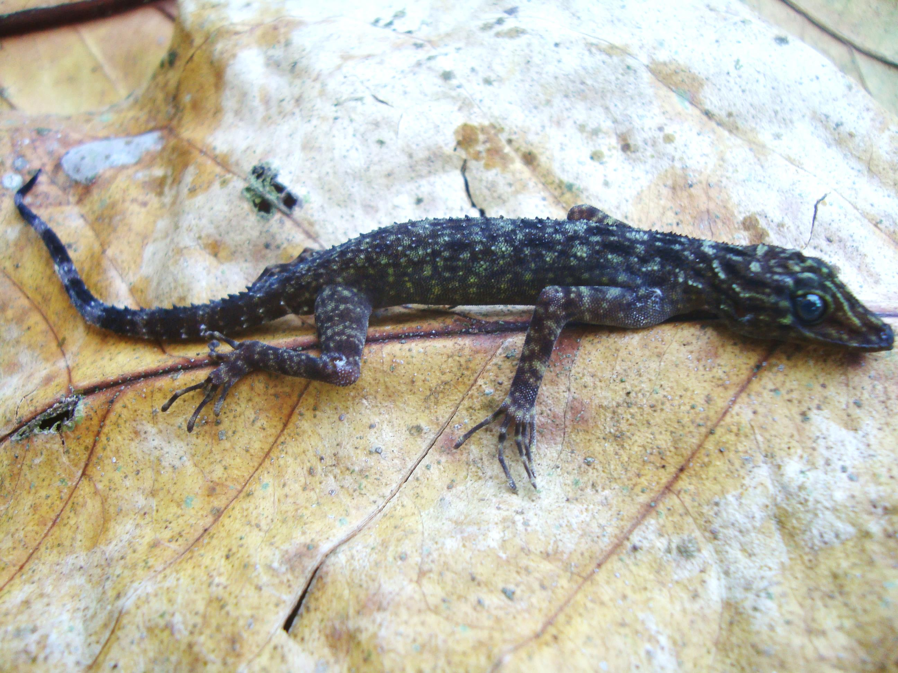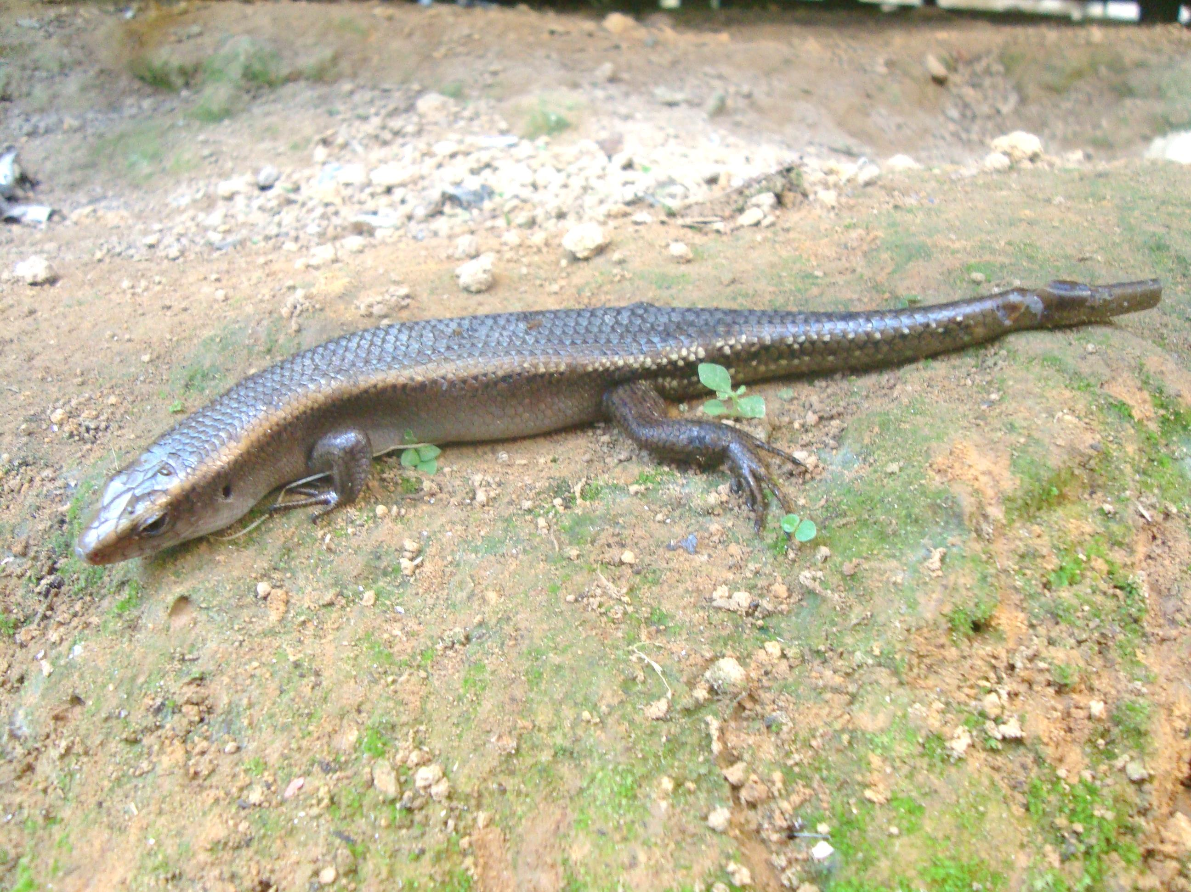
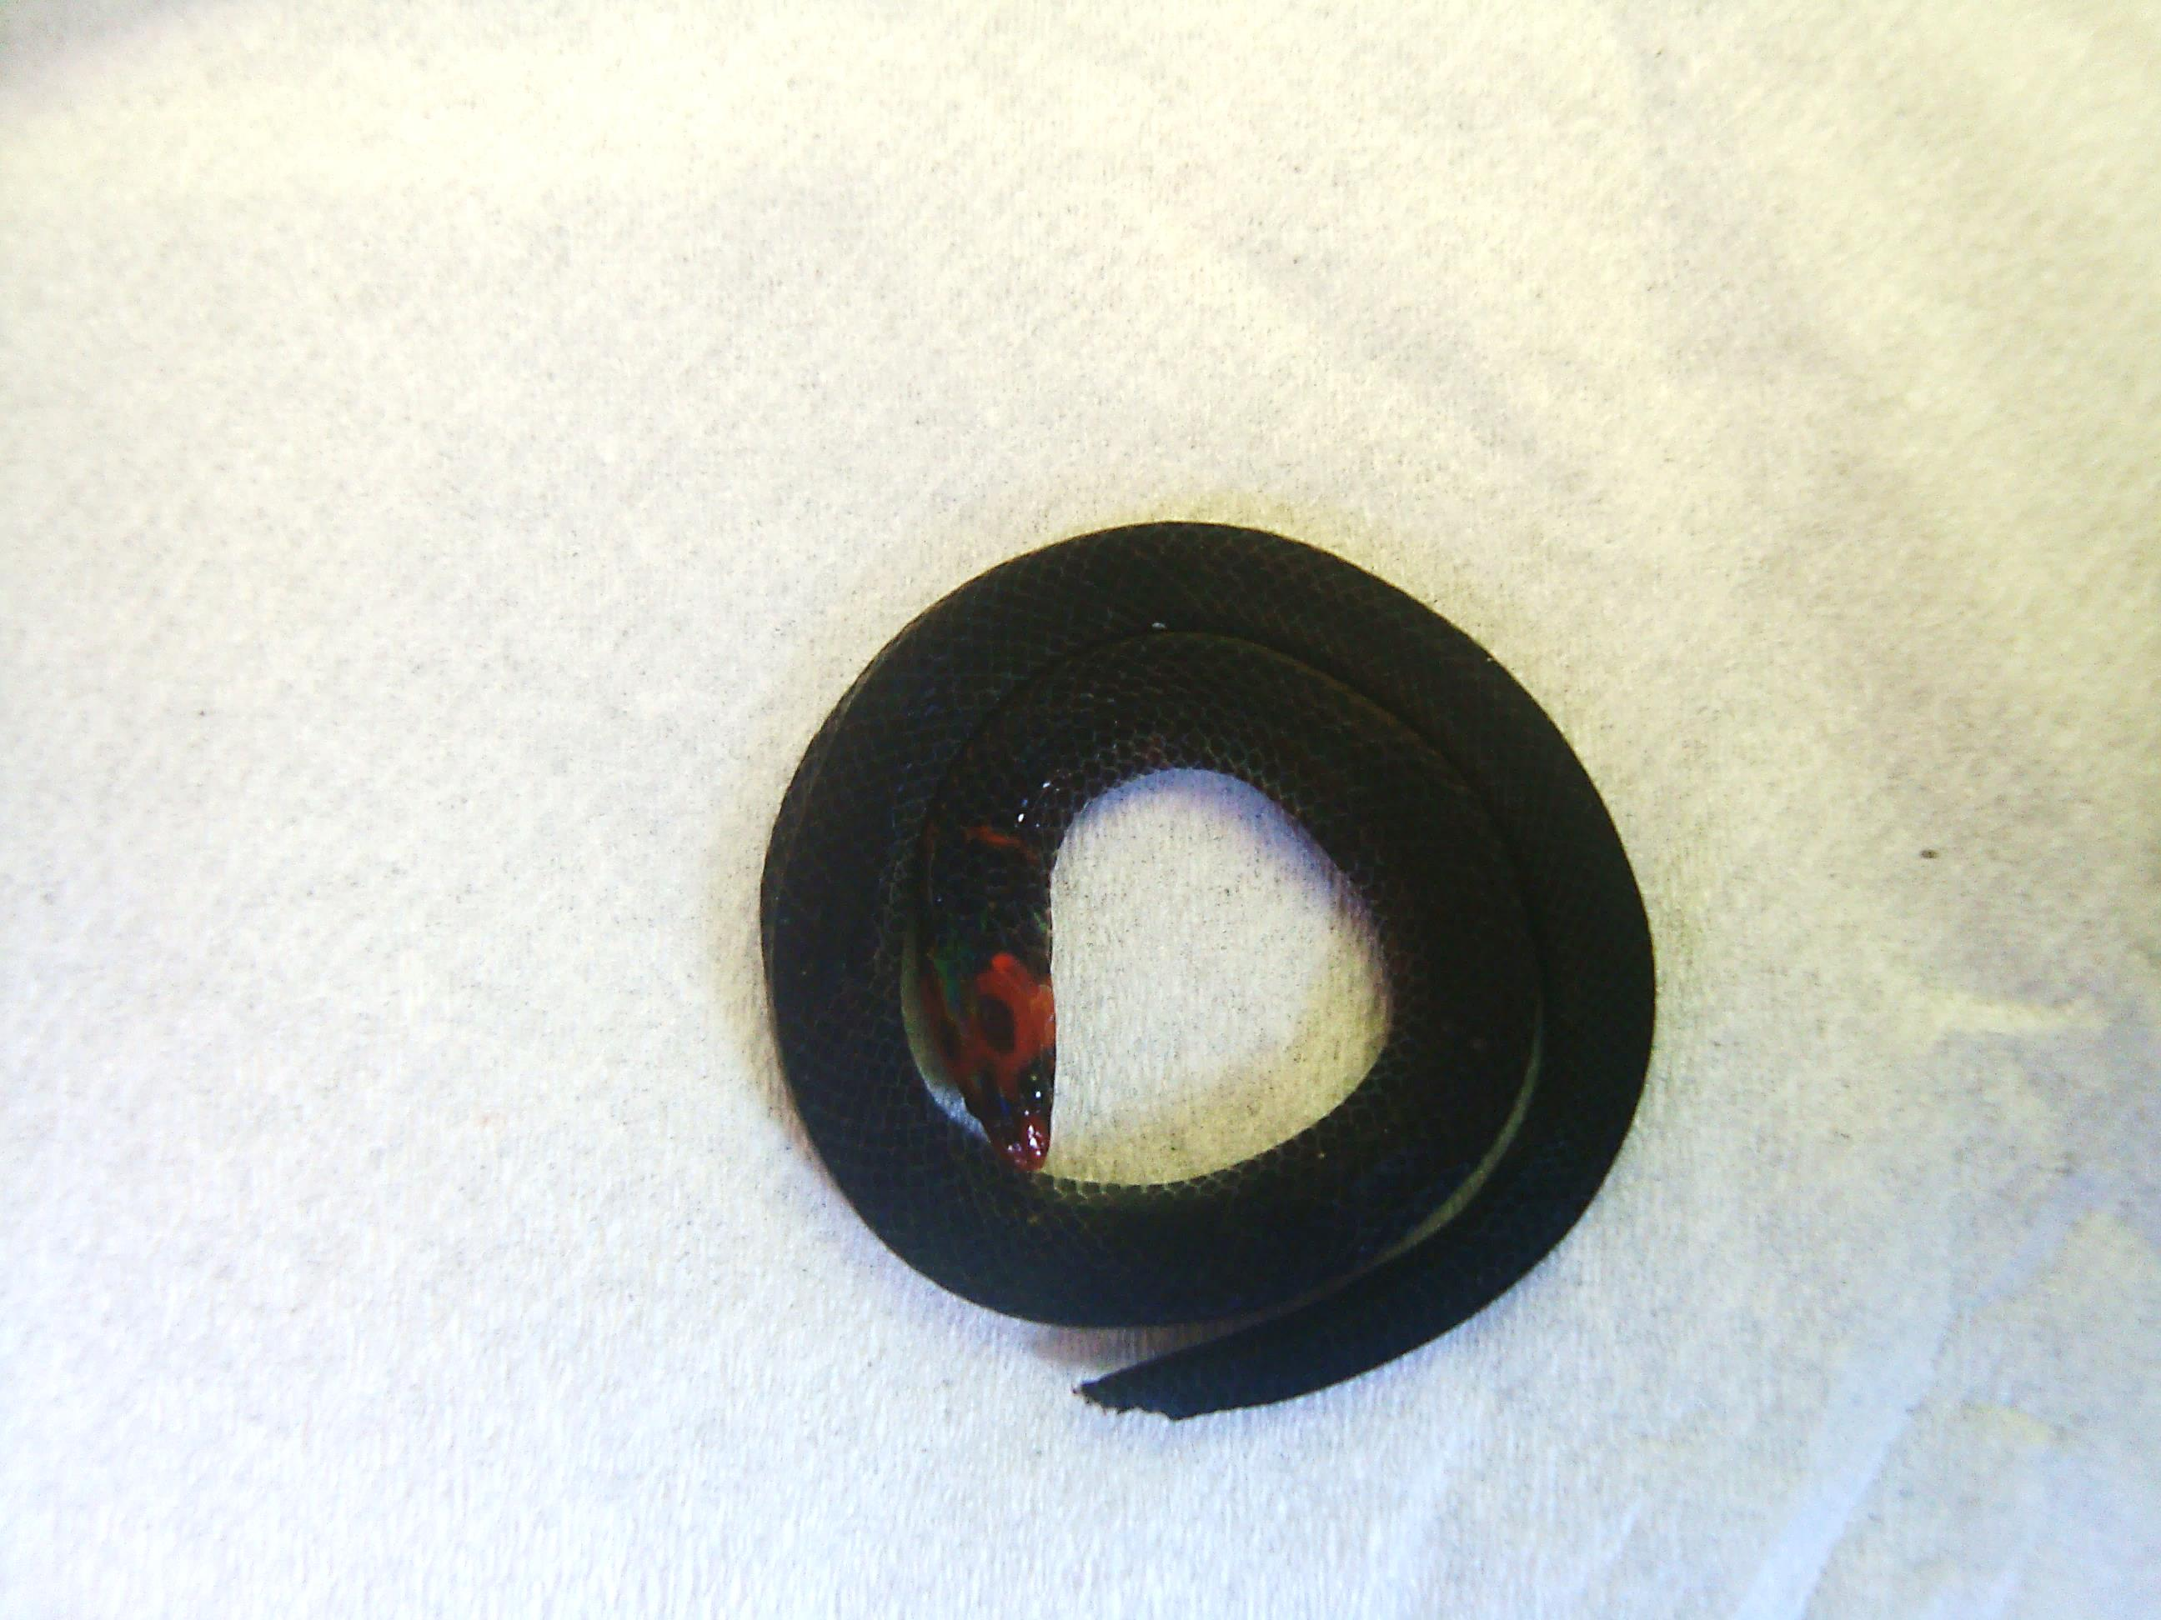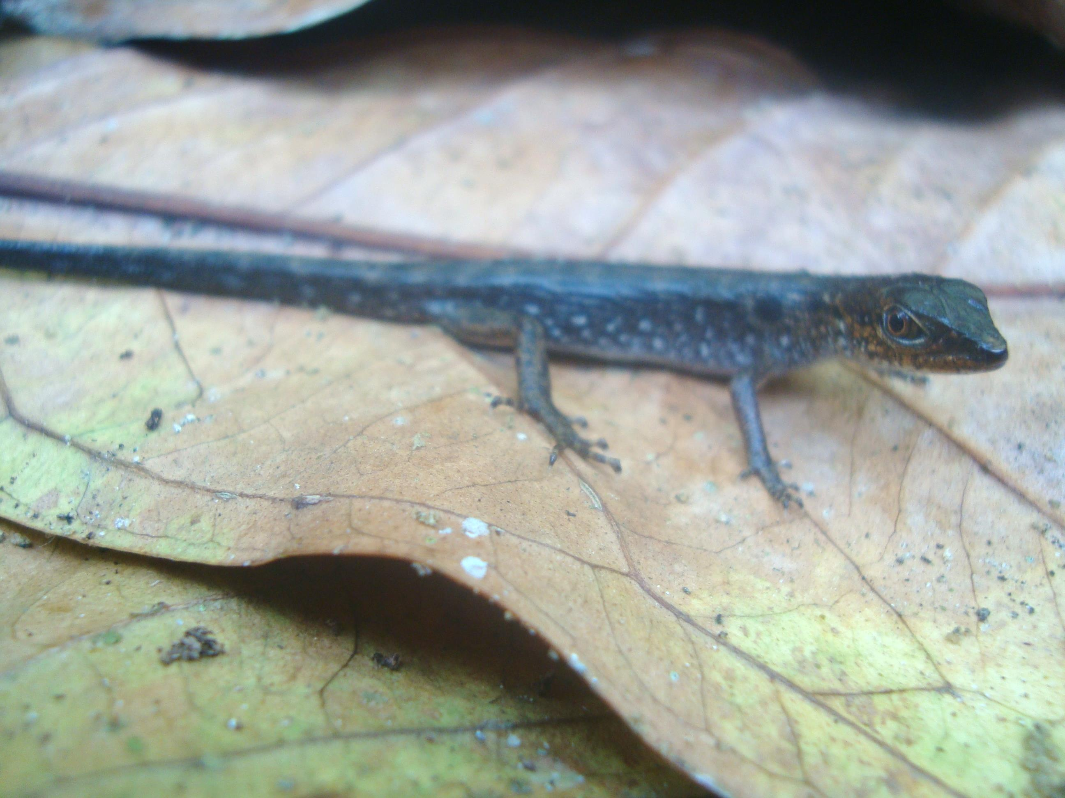
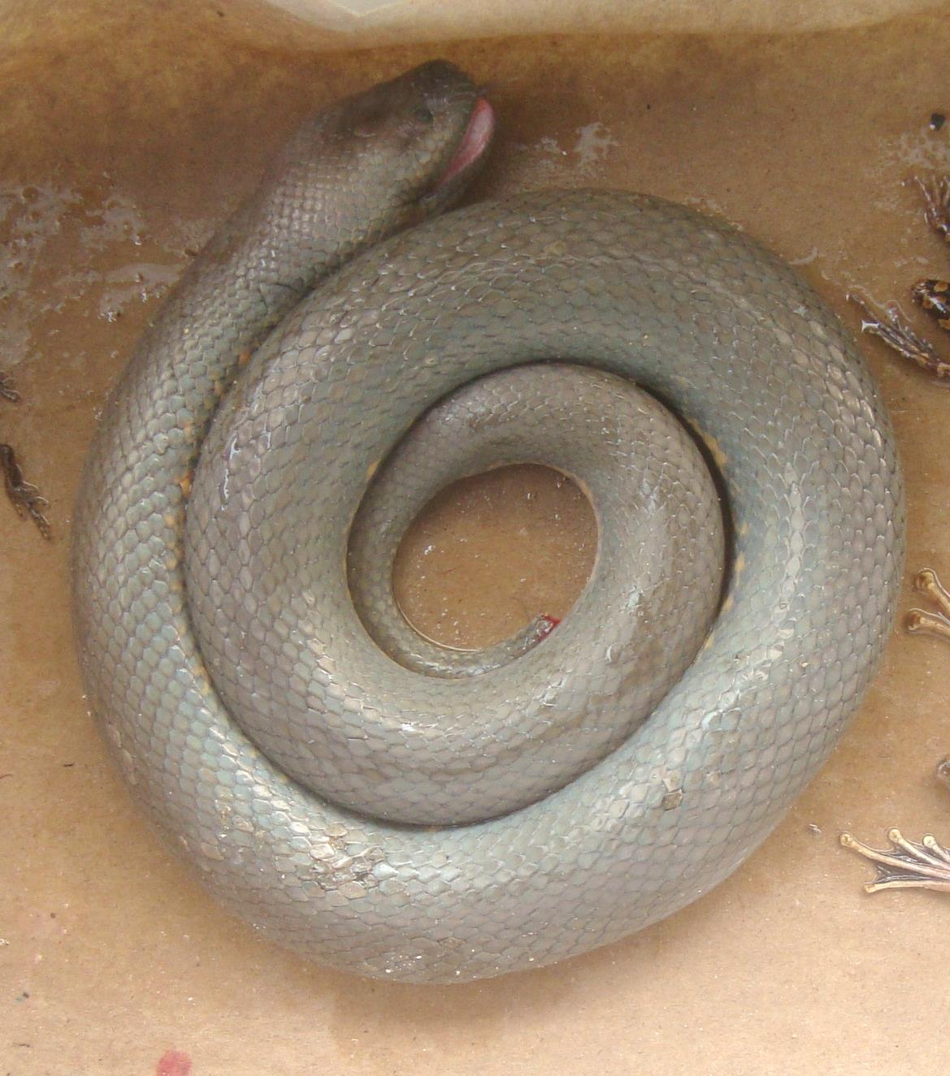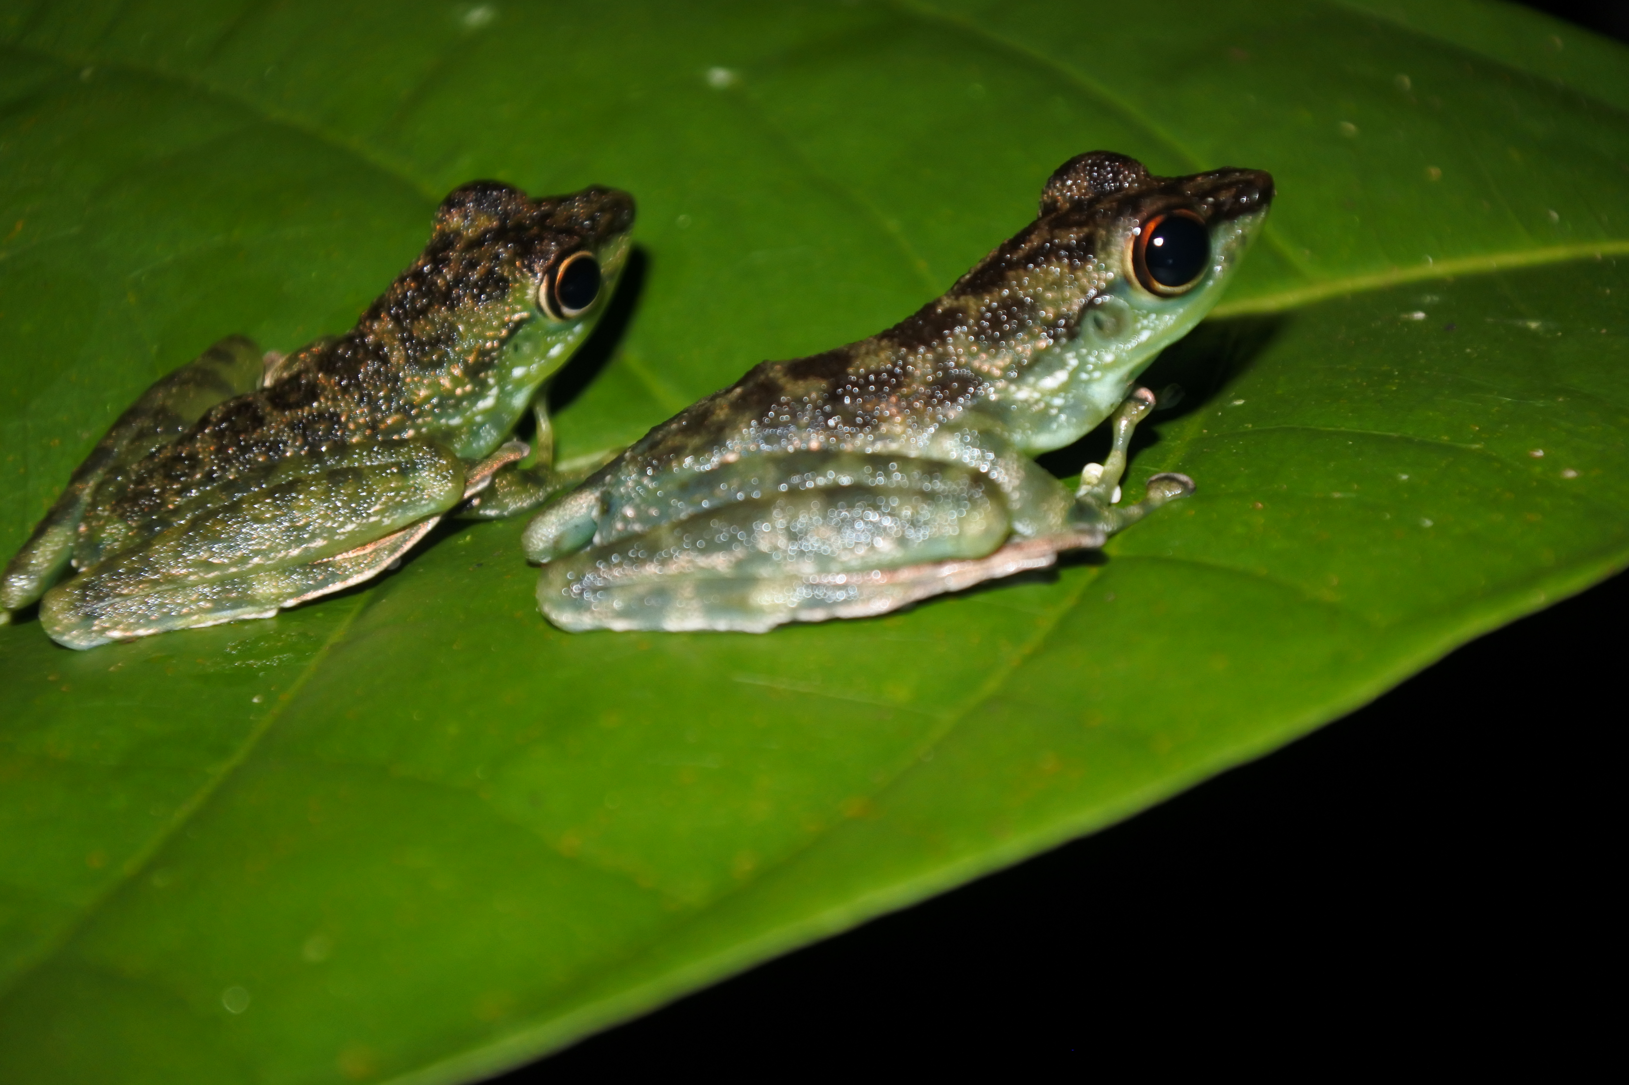

Figure 1. Documentation of the herpetofauna encountered. A) Cnemaspis sp. B) Eutropis multifasciata C) Pseudorabdion sp. D) Tropidophorus beccarii E) Enhydris sp. F) Staurois guttatus

A
B

D
C

F
E

